Q-1: What is the difference between Java & JavaScript?

Ans: - Different between java and JavaScript: -

|  |  |
| --- | --- |
| Java | JavaScript |
| This is OOP or Object-Oriented programming language | This is an object-based scripting language |
| A stand-alone language | Not stand-alone, incorporated into HTML program for operation |
| Strongly typed language is used, and data type of variable is decided before declaring or using it | Language utilised is loosely typed, so that the user does not have to worry about the data type before the declaration |
| Code has to be compiled | The code is all text |
| Is static and the code once written can be run on any computing platform | Dynamic and is a cross-platform language |
| Large amount of memory is required | Memory consumption is lesser |
| Programs are saved with “.java” extension | Programs are saved with JavaScript, “.js” extension |

Q2. What is JavaScript?

Ans: JavaScript is a scripting language for creating dynamic web page content. It creates elements for improving site visitors’ interaction with web pages, such as dropdown menus, animated graphics, and dynamic background colors.

Q3. What are the data types supported by JavaScript?

Ans: There is 8 data type supported in JavaScript: String, number, An object

Example:

|  |
| --- |
| //numbers:  Var length=15;  //strings:  let colour = “Yellow”; |

|  |
| --- |
| //Object:  Const person = {Name: “Nirmal”, Roll no: “nirmalumarvanshi@gmail.com”}  //Array:  Const name = [“nirmal”,” sagar”] |

Q4. What are the scopes of a variable in JavaScript?

Ans:  JavaScript variables have different scopes, they are:

* Global Scope
* Local Scope
* Block Scope
* Function Scope

Global scope: Any variable declared outside of a function is said to have Global Scope. in simple terms, a variable that can be accessed anywhere in the program is known as a variable with global scope. Globally scoped variables can be defined using any of the three keywords: let, const, and var.

|  |
| --- |
| // Global variable in JavaScript    Var name = “nirmal”;  Function show () {    Console.log(name)  } |

Local variable: Any variable that you declare inside a function is said to have Local Scope. You can access a local variable can within a function.

|  |
| --- |
| Function show () {  Var name = “nirmal”;  Console.log(name)  } |

Block scope:

In the block scope we can not access the variable out side the block which is declared inside the block. The block scope is work with var variable only, it does not work with let and const variable.

|  |
| --- |
| {  Var name = “nirmal”;  }  Console.log(name) |

Q5. What is callback?

Ans: callback: A callback is a function passed as an argument to another function. This technique allows a function to call another function. A callback function can run after another function has finished.

Q6. What is Closure? Give an example.

Ans: JavaScript variable can belong to the local or global scope.

Global variable can be made local (private) with closures.

|  |
| --- |
| Example:  Function show() {    Var a = 10;  Return a*a;  }  Console.log(show())  But function can also access variable defined outside the function, like this:  Let a = 10;  Function show() {  Return a*a;  }    Console.log(show()); |

Q-7: What is the different between the operators ‘==’&’===’?

Ans: The operators ‘==’ is check whether value is equal or not, this operator does not compare the data type of two value. The operator ‘===’ is compare the value of two variable as well as the data type.

Q-8: What is the different between null & undefined?

Ans: Null: It is the intentional absence of the value. It is one of the primitive values of the JavaScript.

Undefined: It means the value does not exist in the compiler.

Q-9: What would be the result of 2+5+”3″?

Ans:

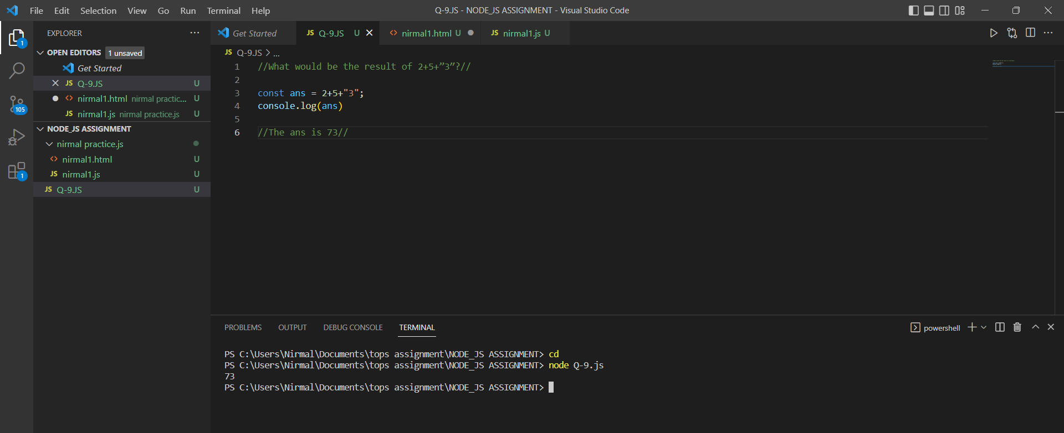

Q-10: what is the different between the call and apply?

Ans: The call method takes argument separately. And apply method takes arguments as an array.